MOCA (Qld) President’s Report
Nov 2025
Hello to all members, and welcome to any new members.
What a great month, we held our Christmas Party at Kedron Wavell RSL, The Staff were excellent, What a great night, good food and good company, thank you all that attended, and a big thank you to the Organisers well done, and a thank you to Hugo for keeping us entertained with the joke recitals.
Lucky Door prize winners were:
Peter New, Glenda Hall, Jenn Hayes, Daryl Fidge, Gloria, Rod Landsdowne, Di Dunford,
Jane Bailey, Robyn Messenger, Steven Roberts
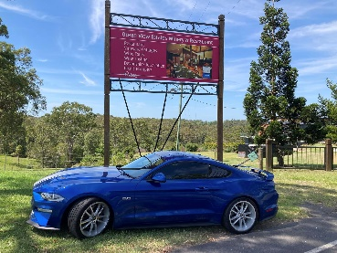
The Dec club run to Ocean View Winery was another great day, well done to the run coordinators. And club members who attended.
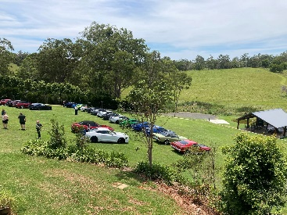

Remember to RSVP for the first run in 2026 which is on Sat 3rd January.
There are some great runs and events planned for next year, come along and join the fun
Perth Nationals are in March, so don’t forget to book.
Holliday season is nearing; this means new school leavers out and about so drive carefully.

See you on a run or meeting
Here’s the Quiz, What year did Carroll Shelby produce “Little Red”

What was the smallest engine size fitted to a production mustang? 2.3 Litre

Cheers
NdSM

