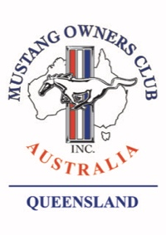
MOCA(QLD) President’s Report
March 2025

Hi members and welcome to the March President’s note.
To repeat last month’s advice, the MOCA(QLD) State Concours will be held on in conjunction with the RACQ MOTORFEST to be held at the RNA showgrounds June 15th.
To attend you must complete two (2) entry forms, the RACQ registration, these will be released on March 10, and is to be completed on-line. When filling in the form, in the Car club field please enter “MOCA(QLD)” and in display category “American”. Then you must complete a MOCA(QLD) Concours entry form. This will be available later this month. Please note there is only room for 50 MOCA(QLD) cars in our allocated area, so it will be first in best dressed. The area we have been allocated is a hardstand with fairly easy access.
If you are contemplating coming along enter NOW do, not put it off
Martin will announce the date of the information/training sessions shortly. One for concours entrants on how to prep your car for judging, a second for prospective judges. In this session the QLD Chief Judge will run through the process of concours judging hopefully recruiting a few more judges both male and female.
Following a number of requests at the March meeting, over the next few months I will again put on my technical oil chemists’ hat and give two more presentations, one on engine coolants and the other on greases.
The club rooms went through the cyclone with only minor water ingress downstairs, the VP is going to respond to a BCC request for cyclone feedback to see if they can stop the water entry into the future.
The Monthly club runs are a great success but all due to the effort of one or two people, I again ask, can a few other club members put their hand up to help out.
Cheers
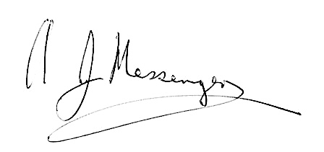
Alan M

