**Mustang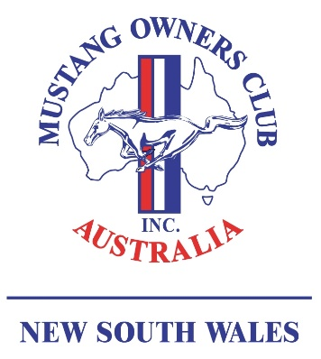 Owners Club**

**Australia (NSW) Inc.**

#### Membership Application

#### 

Annual Membership Fee $75.00 Date

Day Month Year

**Please print clearly**

# First Name Spouse/Partner

# Surname Spouse/Partner

(Only If Different)

Children(s) Name(s) (if under 18)

# Address

P Code

# Phone Home Work Mobile

# Email

# Occupation Company

## *MUSTANG Information* - please complete the section below with as much detail as is available. (Please continue over if insufficient space is available).

| **Body Style** | **Year** | **Eng.**  **Size** | **Rego #** | **Colour** | VIN Number |
| --- | --- | --- | --- | --- | --- |
|  |  |  |  |  |  |
|  |  |  |  |  |  |

If paying by direct deposit – Pay to MOCA NSW, BSB: 062139 ACC: 00903078 – and use your surname as reference.

If paying by cheque/money order – please send with this application to MOCA (NSW), PO Box 289, St Ives, NSW, 2075

If you wish to also become a member of the Merrylands RSL Club (where we hold our Monthly Meetings), at no additional cost, you should apply direct to the RSL Club, noting *‘MUSTANG’* on the application. MOCA members are not required to complete the “proposer” and “seconder” section.

Who introduced you or how did you find out about MOCA?

I/We agree to support the Mustang Owners Club Australia (NSW) Inc. and to abide by the Rules in the Club Constitution & By Laws.

Signature: